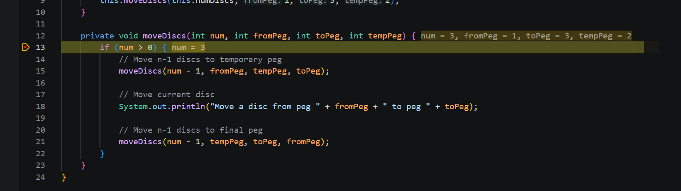
Screenshot 1: Initial call where num = 3

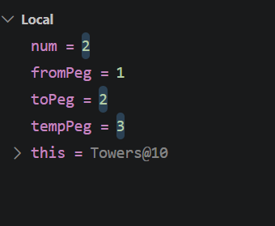

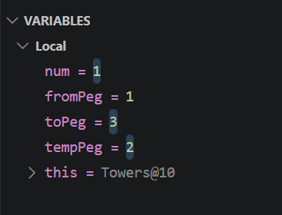
Screenshot 2: Recursive call where num = 2

Screenshot 3: Recursive step where num = 1

